**20th July Report**

**Quick UI fixes**

We checked on this and found out there was trully a double ll on the word `Availlable views`. one `l` should be omitted. However we did not come accross a duplicate anywhere.

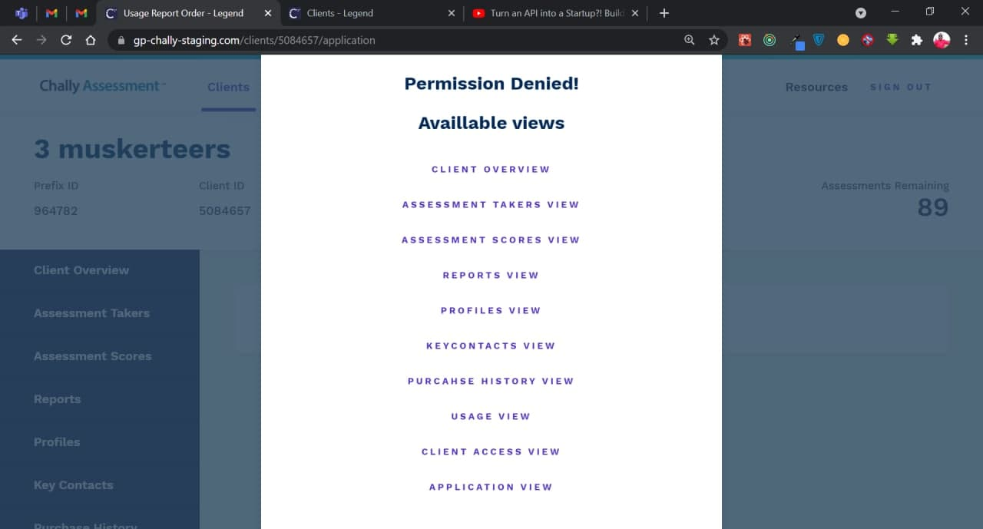

On the banners that consist of chally clients names we noticed that on both the client- admin and chally admin (since we have acces to this sections only) there is a space being left at the end of the banners. This happens when we zoom into the browser. We noticed that since not all the clients will keep their resolution at 80% where everything is visible in the whole screen.

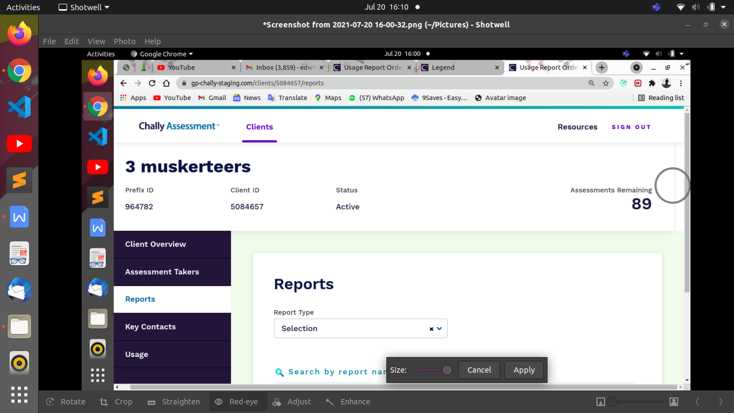

**Bugs**

On chally admin > Usage tab

On the report receiver, select input key even key contact added as client admin(red arrows) can be selected to receive report other than only key contacts added as report receiver (blue arrows).

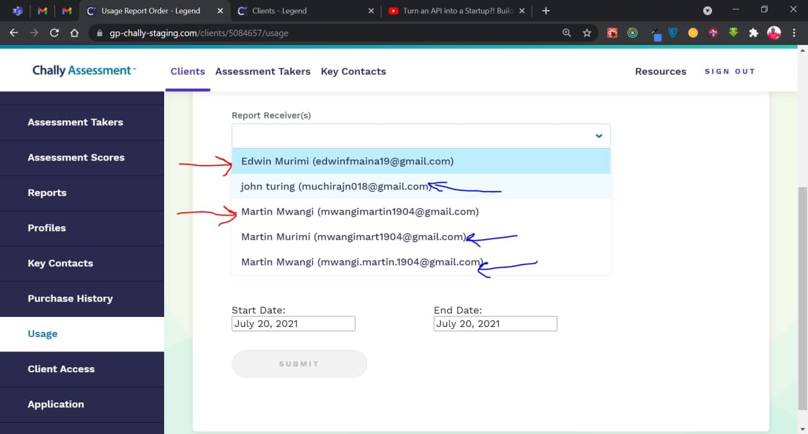

Under usage

Notice after selecting the report receiver the submit button activates. We thought that is inappropriate since we have not selected the report type we want our particular report receiver to get. This returns a success message and after sometime returns an internal server error message.

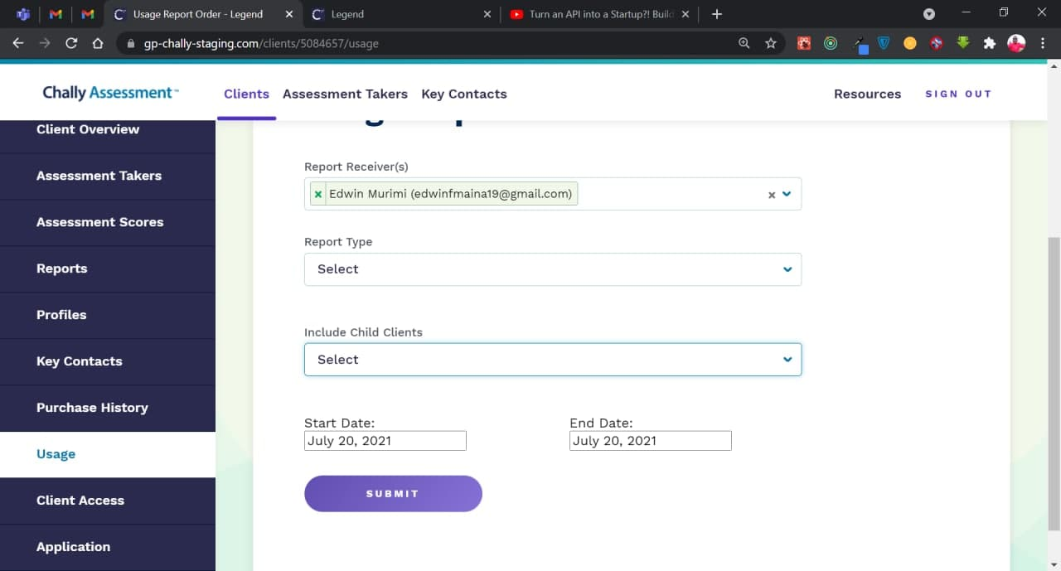

Under assessment scores

On the select profile dropdown we can select even the profiles not in our organization.

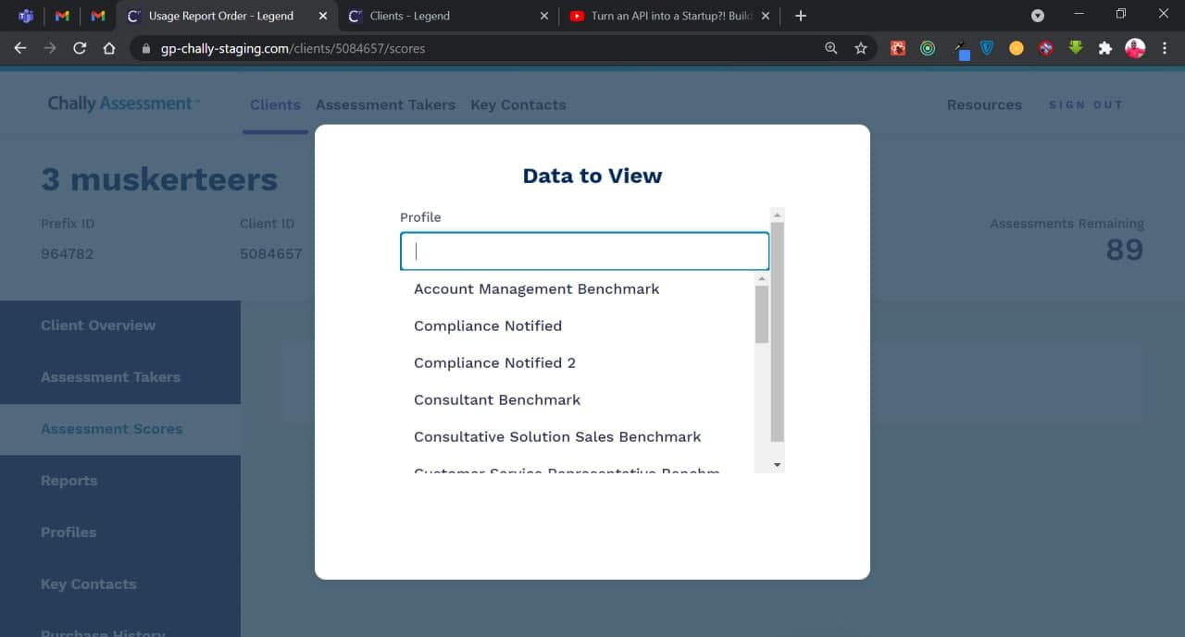

In addition to that it is not displaying any assessment takers in the drop down `Assessment Taker(s)` even though we have existing assessment takers in our organization.

